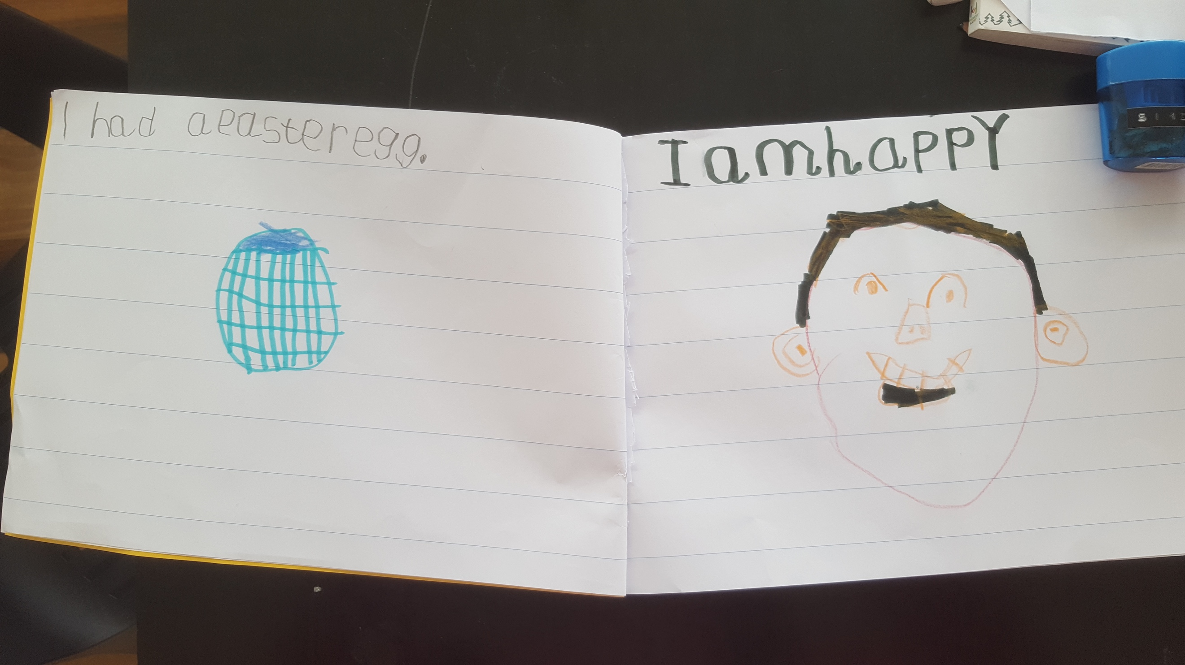

Kael Frederick PrepP

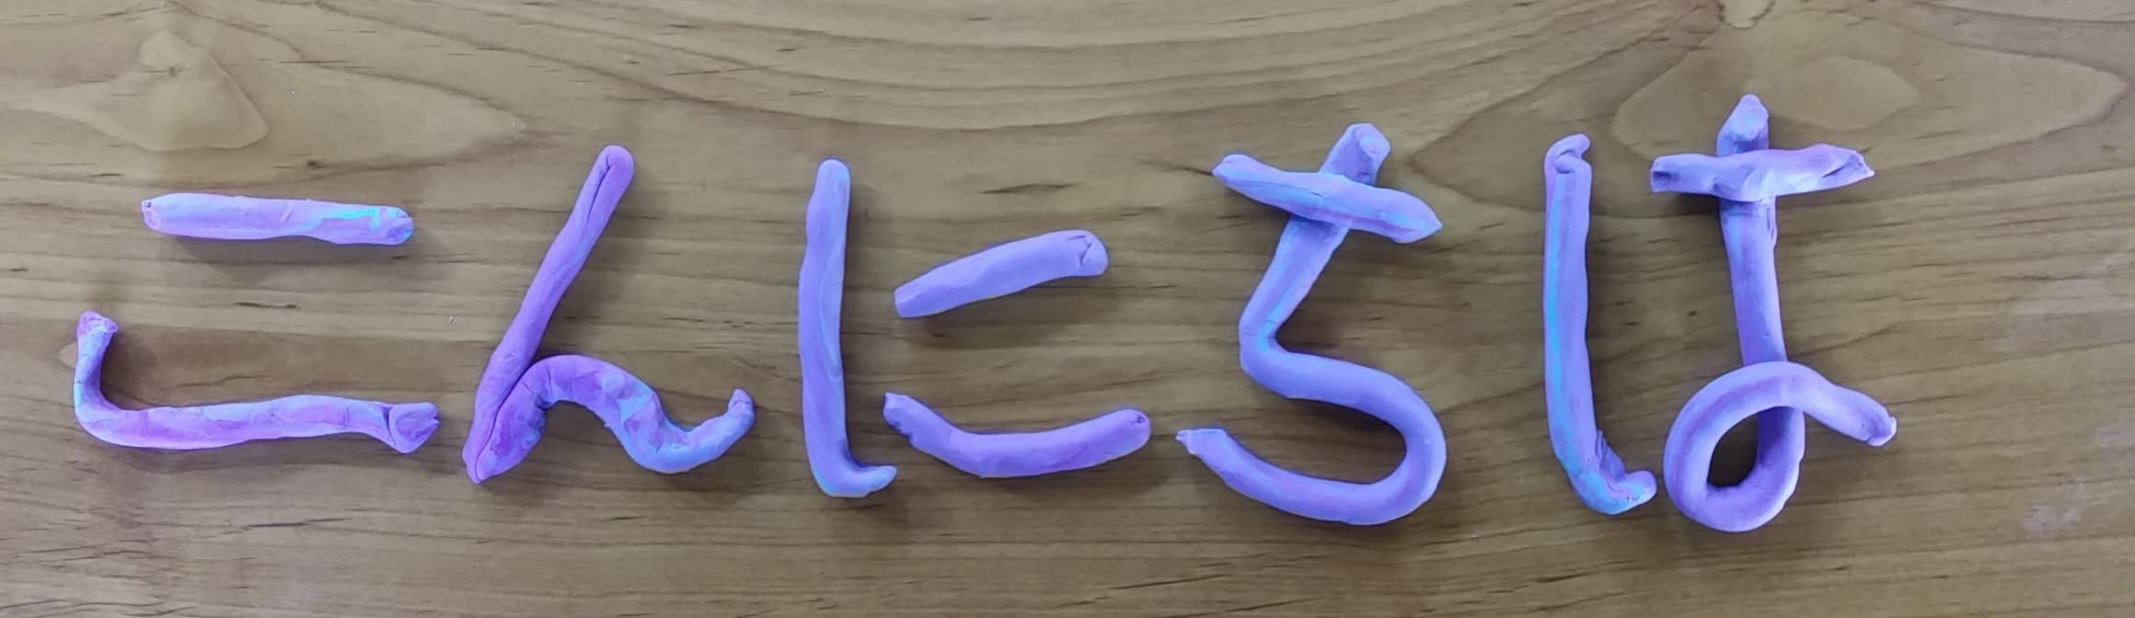

Eleanor Chlebna - writing hello, practising her hiragana

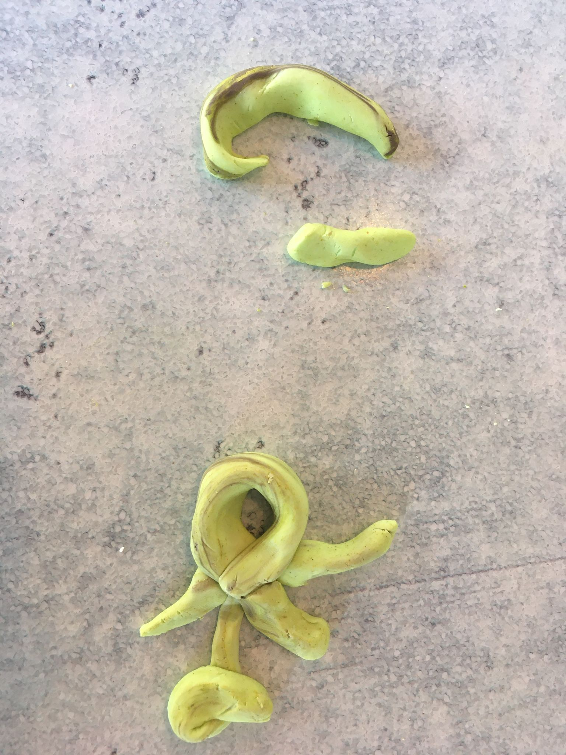
Erica Blake

