Some more examples of student work completed remotely:

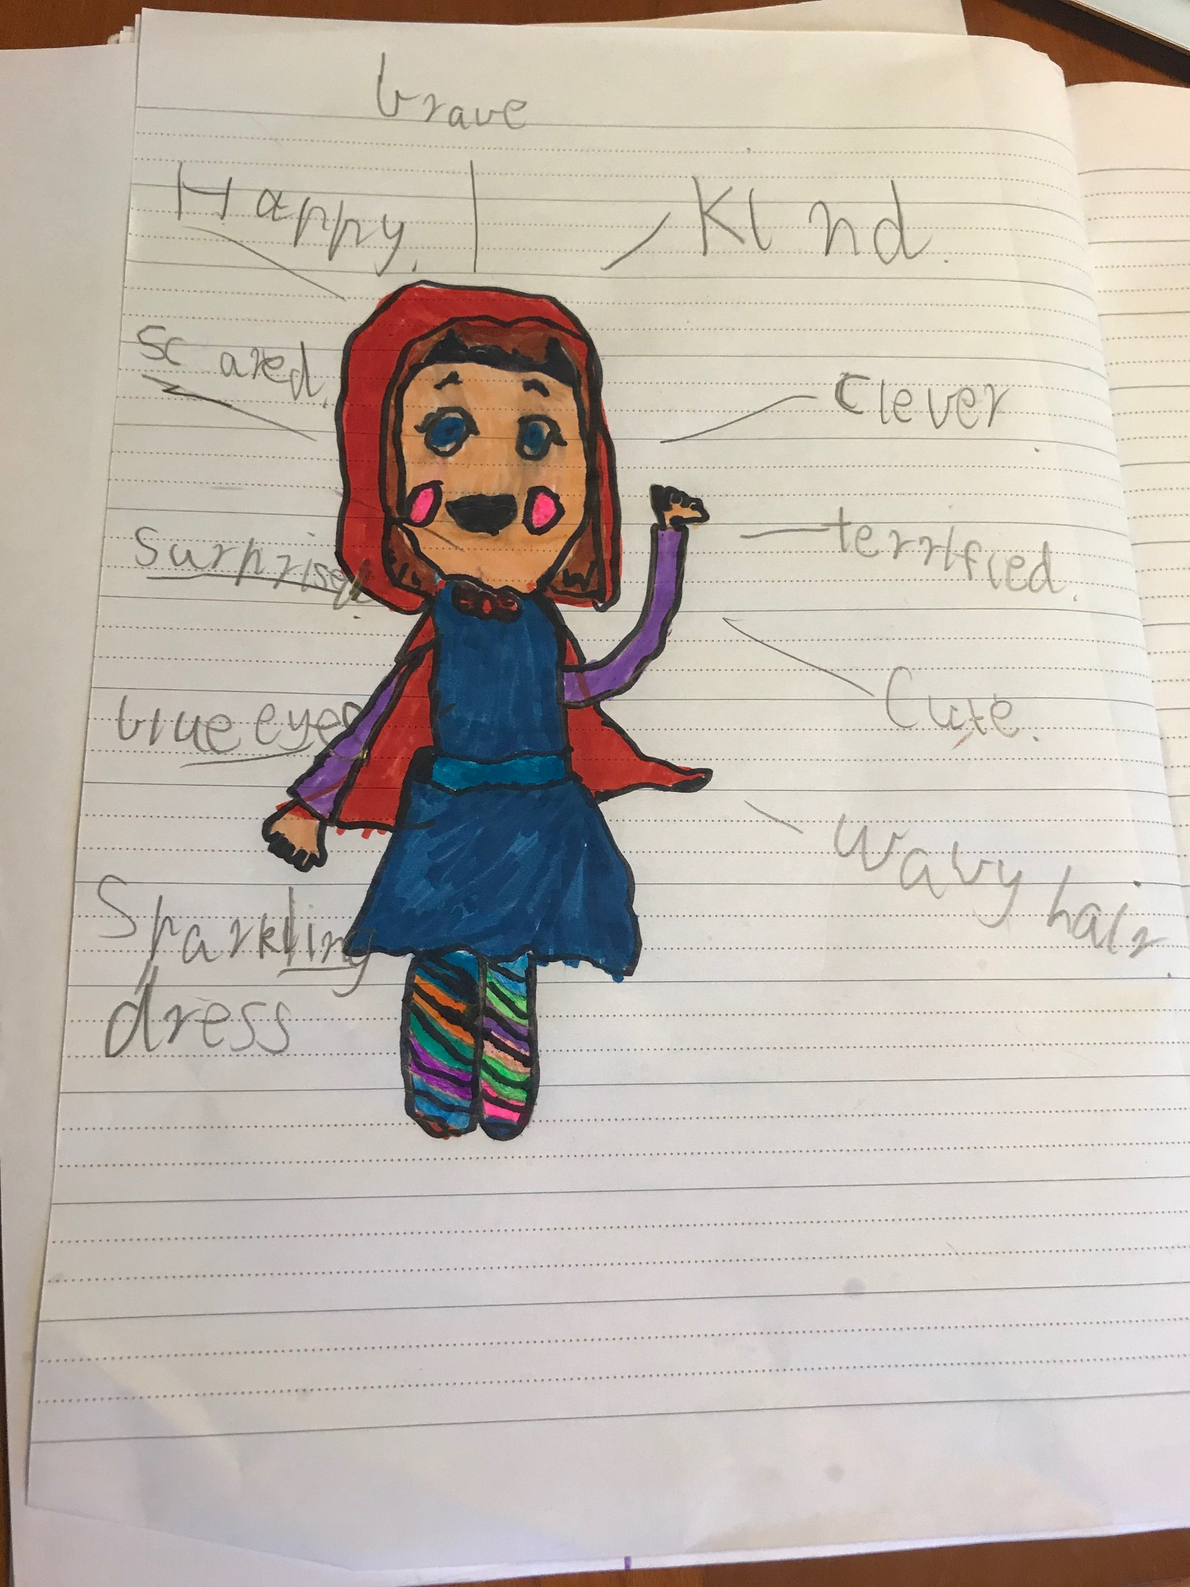
Hannah O’Neill 1/2O

Written article by Dot Michie, Year 6

No Quarantine for Animals!
Should animals be kept in zoos? No. I’m against that for many reasons… 1- It’s hard for us in quarantine? Imagine that for life!
Animals kept as hostages, spend up to 20-30+ years, or all their life in fence exhibits. And not just zoos. There's this TikTok that I saw, and I searched about it, and what it said is true. The man explained how we’ve only spent a few weeks in quarantine and we are already bored.

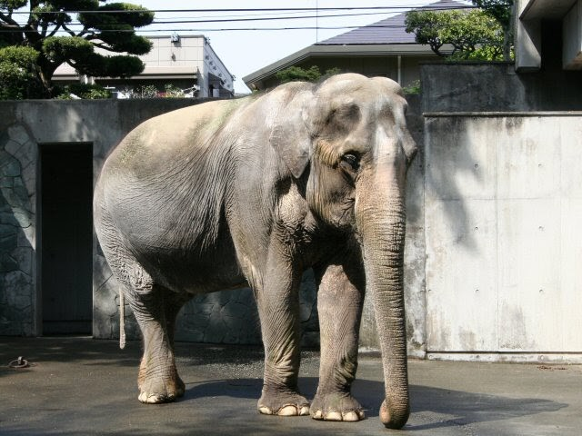
Well imagine this… Hanako the elephant spent 60 years in a concrete enclosure, unable to see any other elephants while there. The enclosure involved no grass or trees, nothing, remembering she spent 60 years like this.

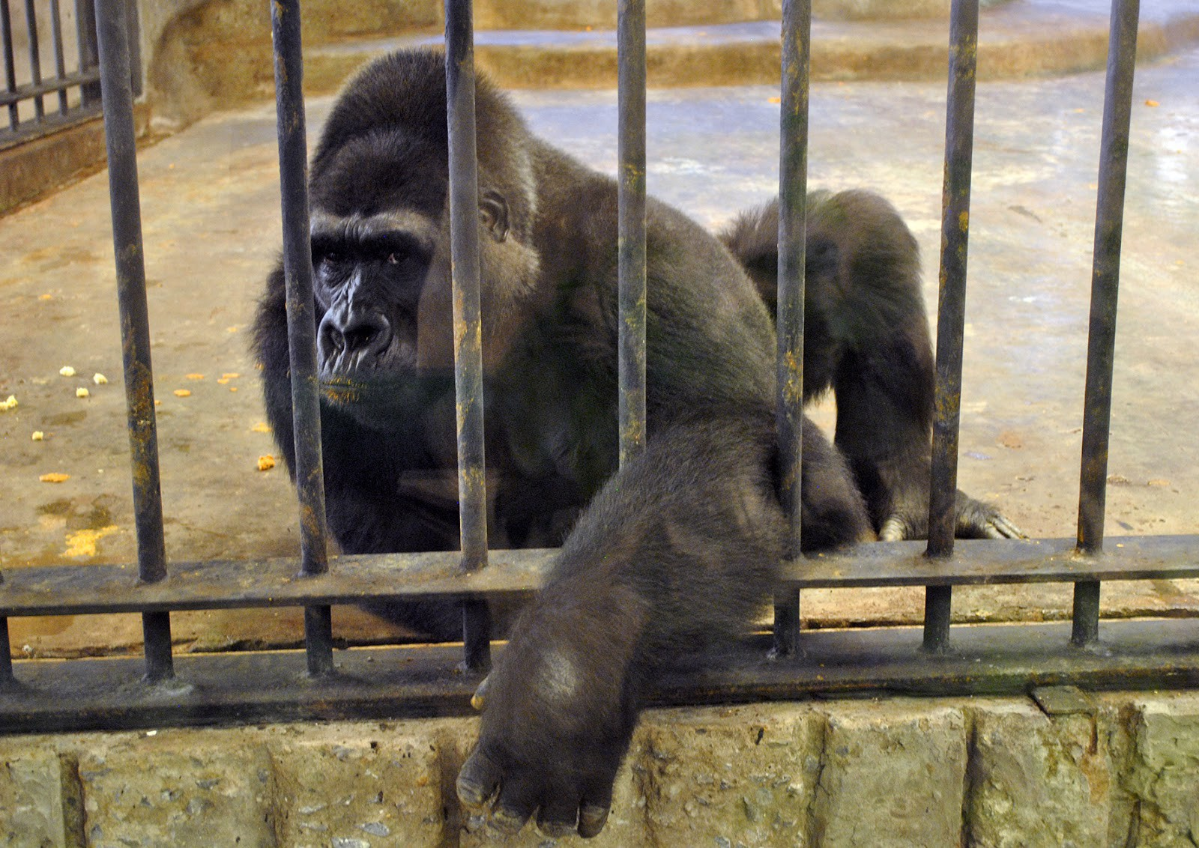
Another, Bua Noi the gorilla. Spent 30 years in a shopping mall, in a cage being watched everyday. Boredom, loneliness and sadness. Everyday was the same.

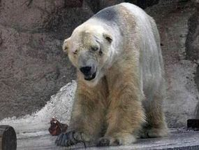
And finally, Arturo the polar bear. Artuto was Argentina's only polar bear, and spent 30 years in a cell. He died of cancer, his nickname has been giving “the saddest animal in the world”.

2-Mental, physical and health problems= miserable.
Animals in such conditions will often feel scared, stressed and sad. They may proceed to grow trust issues and feel not loved. :(
Not to mention their state of physical health. An example - scientists from the National Marine Fisheries Service have proven that oscars have collapsed dorsal fins, due to the minimum amount of space they have to swim around. Which is much less of an area different to the amount they swim (40 miles, on average, per day) out in the wild.

And 3- What’s in it for the animals?
To me, all this seems quite selfish. We shouldn’t be doing this to animals, they are being forced to do shows, been watched at nearly all times, and having their opportunities taken away. I do understand how some zoos are good. Take Australia Zoo for example, they look after their animals, catch one's from the wild that hurt, heal them and then release them back into the wild. That's the way to protect animals, I am not against zoos that do it like that, but am for the ones that leave animals in such bad condition.
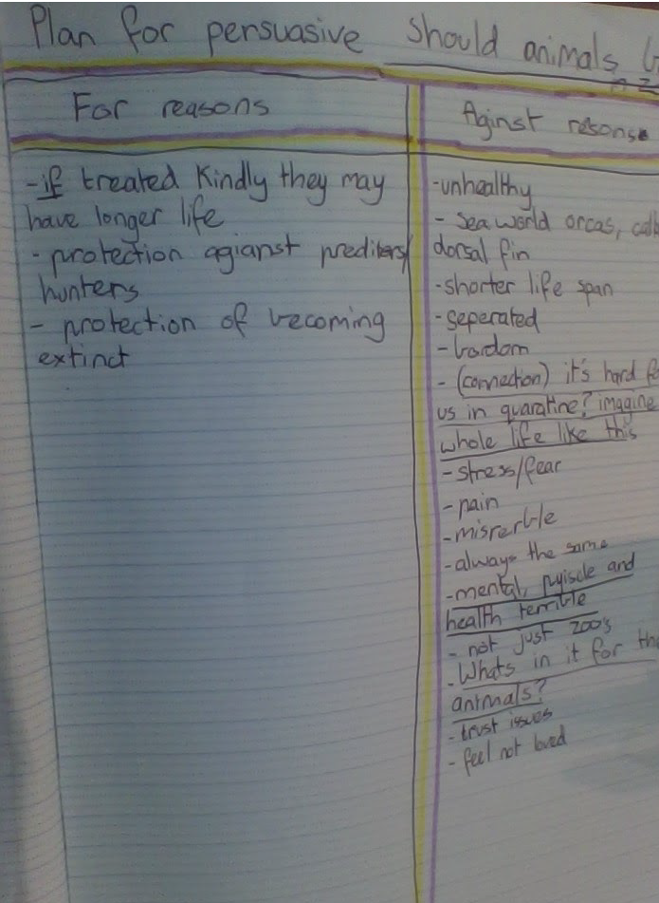
When I wrote down the goods and bads about zoos, from my research, there were more bad, and so that's why I decided to be against it, and look into the negative side of zoos.

So over all, just do the right thing for animals, because they don’t get a say.

